Section 3

Design Page Landing Part 1

* Now we will create a different html file for this
* In CSS d-flex is not a fundamental property instead it is just used as the shorthand form of display-flex
* We will divide it in two sections top and bottom
* Then we will make class g-top -left
* Then we will make a class call-wrap to wrap all the vidoes
* 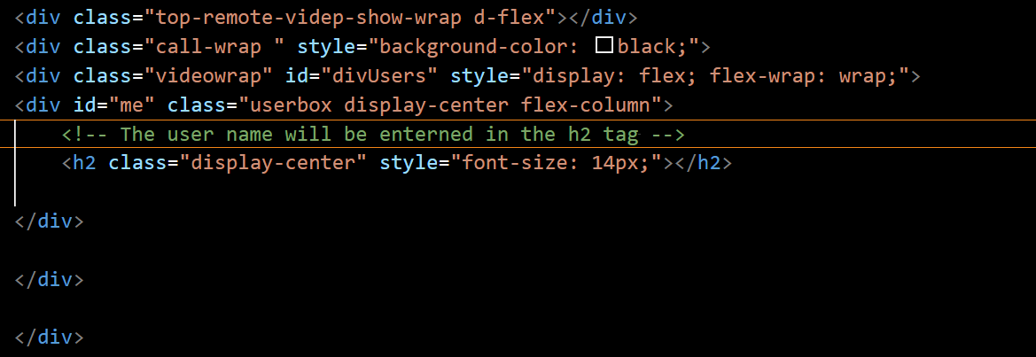
* 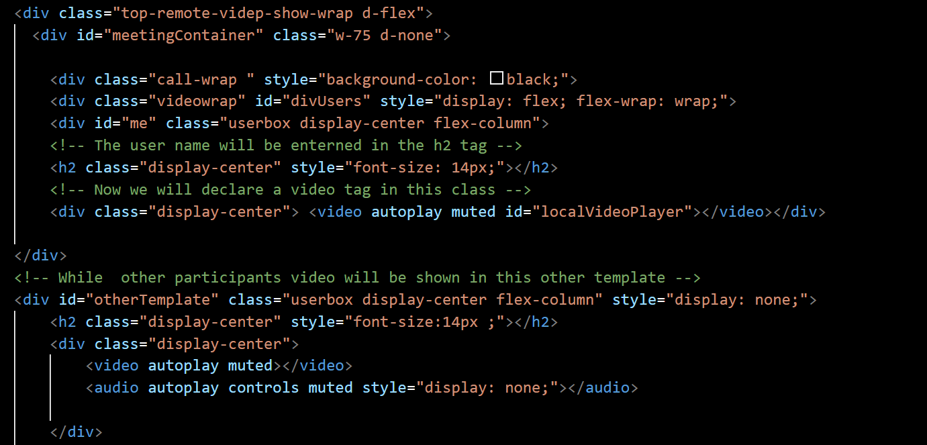
* Here there are two sections local video and other is the otherTemplate so in local video users video will be there from local player while other participants video will be displayed from by using class Other Template
* Home Page Design Part 2
* Now we will work on top-left where we will be creating class for chat,participants name
* 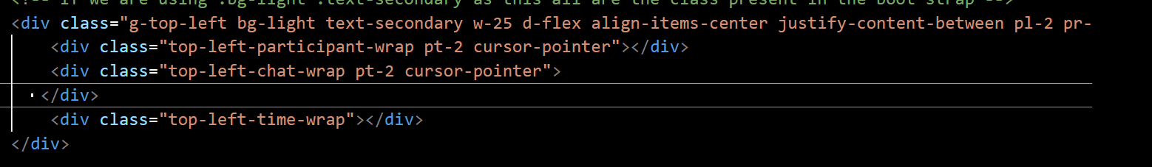
* After adding this we will add icons
* 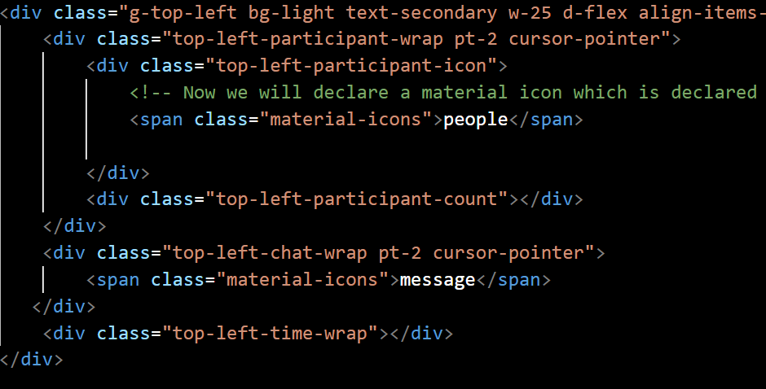
* Now we will move to g-bottom
* 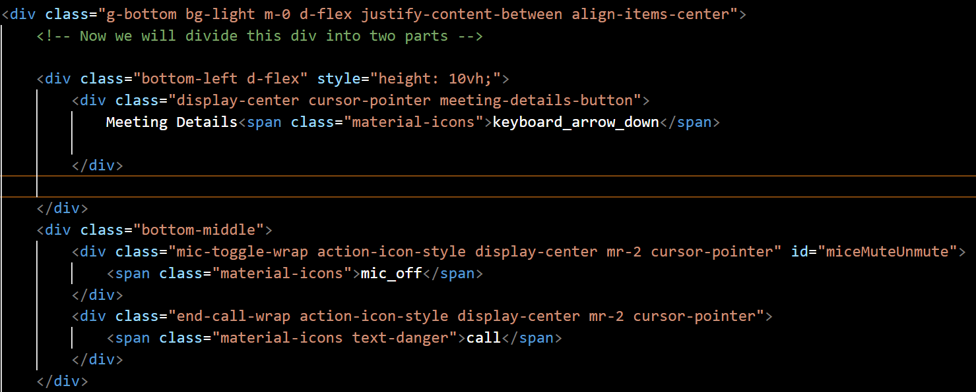

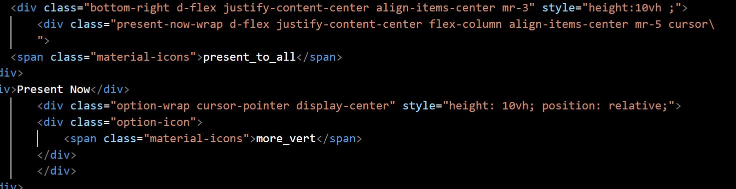

* Design Landing Page Part 3
* Now we will do the changes by applying some css to it
* 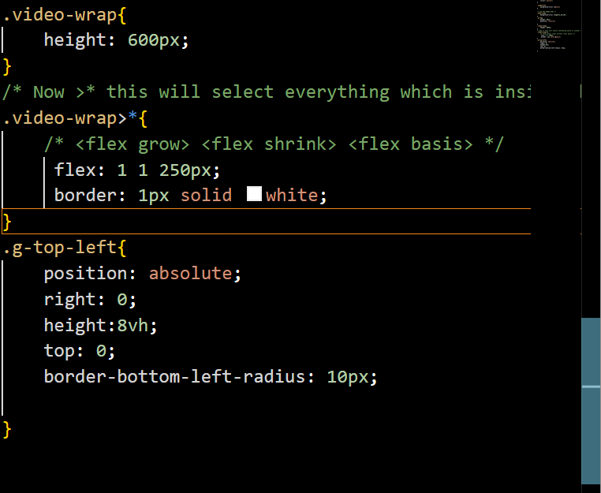
* After doing this we get the output as

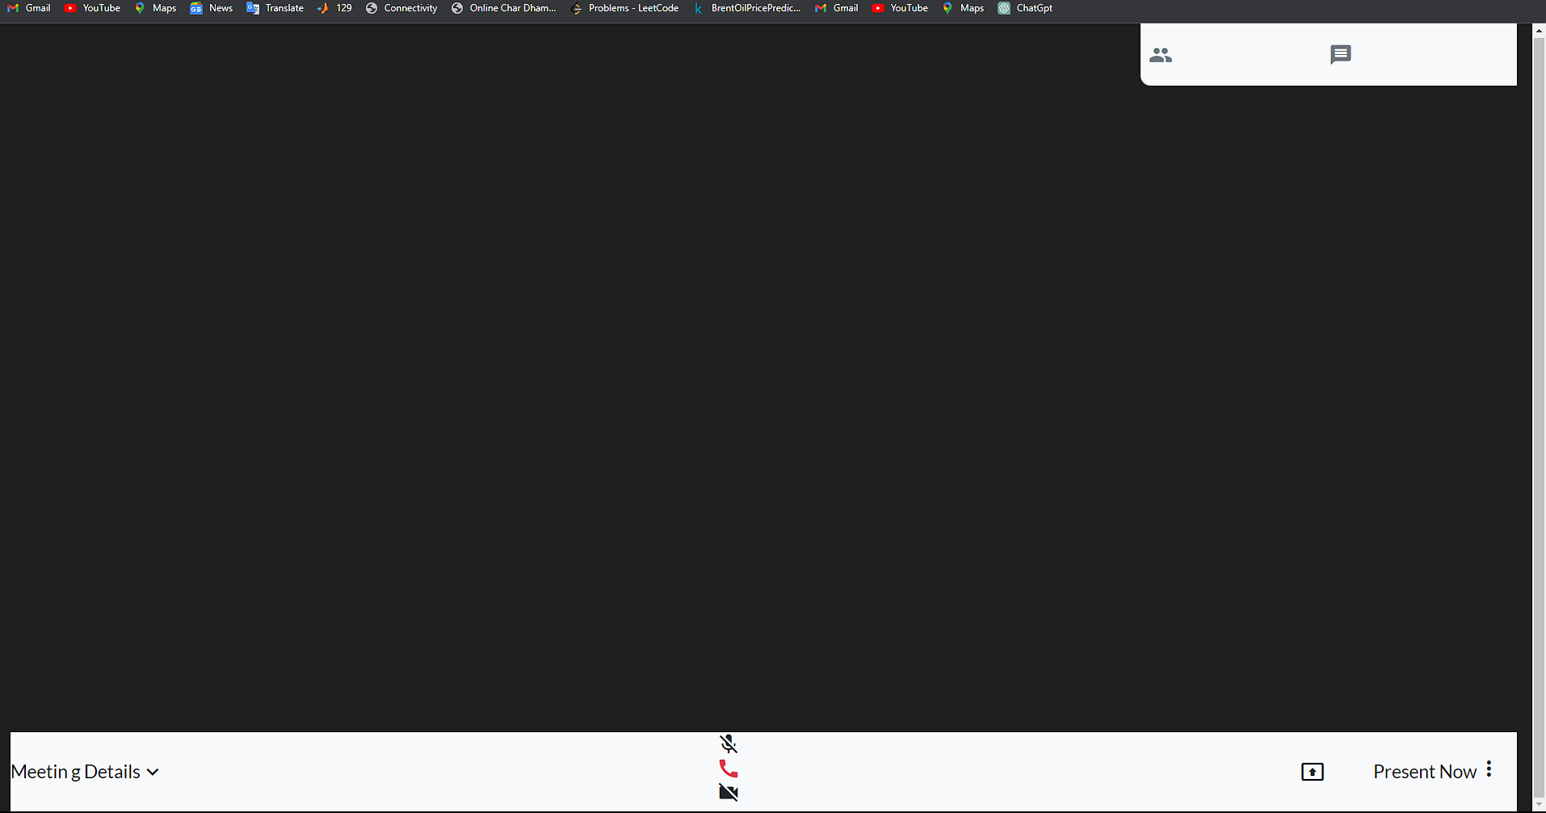

* Now here we can see the usual black colouring in top and bottom line so we will remove it
* So to stop this we will just remove the container-fluid class present in the main tag

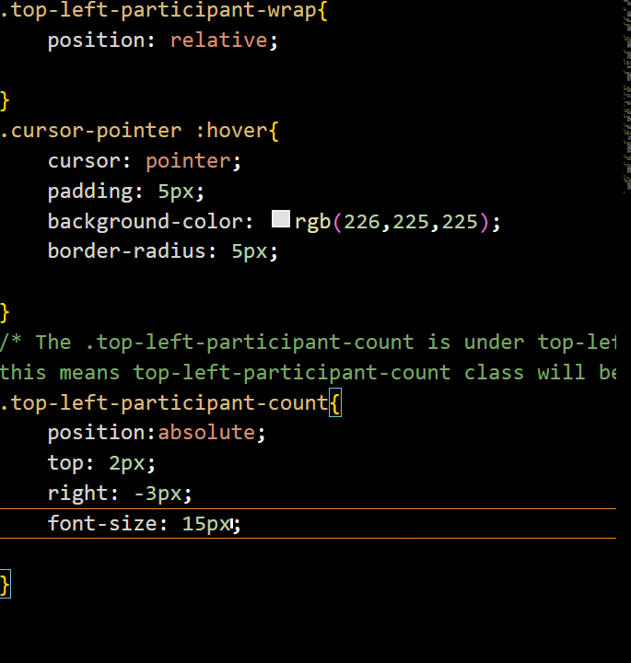

* Here in count it will show the number of participants joined
* 